**K L UNIVERSITY**

**FRESHMAN ENGINEERING DEPARTMENT**

**A Project Based Lab Report**

**On**

**HARRY AND PILE OF BOOKS**

**SUBMITTED BY:**

170040351 **J.V.N.D.S.R.PRASAD**

**UNDER THE ESTEEMED GUIDANCE OF**

**Mrs.SK.RAZIA**

**Asst. Professor**



**KL UNIVERSITY**

Green fields, Vaddeswaram – 522 502

Guntur Dt., AP, India.

**DEPARTMENT OF BASIC ENGINEERING SCIENCES**



**CERTIFICATE**

This is to certify that the project based laboratory report entitled “**HARRY AND PILE OF BOOKS**” submitted by Mr. **J.V.N.D.S.R.PRASAD** bearing Regd. No.170040320 to the **Department of Basic Engineering Sciences, KL University** in partial of the requirements for the completion of a project based Laboratory in PROBLEM SOLVING AND COMPUTER PROGRAMMINGcourse in I B.Tech I Semester, is a bonafide record of the work carried out by him/her under my supervision during the academic year 2017 – 2 018

PROJECT SUPERVISOR HEAD OF THE DEPARTMENT

Mrs.Sk.Razia Dr. D.HARITHA

**ACKNOWLEDGEMENTS**

It is great pleasure for me to express my gratitude to our honorable President **Sri. Koneru Satyanarayana**, for giving the opportunity and platform with facilities in accomplishing the project based laboratory report.

I express the sincere gratitude to our principal **Dr. A. Anand Kumar** for his administration towards our academic growth.

I express sincere gratitude to our Coordinator and HOD-BES **Dr. D.Haritha** for her leadership and constant motivation provided in successful completion of our academic semester. I record it as my privilege to deeply thank for providing us the efficient faculty and facilities to make our ideas into reality.

I express my sincere thanks to our project supervisor Mrs.Sk.Razia for his/her novel association of ideas, encouragement, appreciation and intellectual zeal which motivated us to venture this project successfully.

Finally, it is pleased to acknowledge the indebtedness to all those who devoted themselves directly or indirectly to make this project report success.

By

**170040351 K.V.SAI TEJA**

**170040320 J.V.N.D.S.RPRASAD**

**170040283 JAYANTH CHOWDHARY**

**170040272 G.SAI LOHITH**

**ABSTRACT**

In this project we have to help harry to arrange the books messed on the floor into a pile such that he can read the books according to the given conditions. We have to use strings, sorting, iterations, arrays…. In this project we have to scan a number(n) and then we have to scan n lines containing the no of remaining exercises in the book and then we have to scan the string denoting the name of the book and then if there is -1 in the scanned array we have to do the sorting to find the minimum no of book exercises and then we have to count the no of books above the required book and we have to print the number followed by the name of the book we have taken to read and this is done until we reached the last -1.

**INDEX**

|  |  |  |
| --- | --- | --- |
| **S.NO** | **TITLE** | **PAGE NO** |
| 1 | Introduction | 6-7 |
| 2 | Aim of the Project | 8-9 |
| 2.1 | Advantages & Disadvantages | 10 |
| 2.2 | Future Implementation | 10 |
| 3 | Software & Hardware Details | 10 |
| 4 | Data Flow Diagram | 11-12 |
| 5 | Algorithm for each module | 13 |
| 6 | Implementation | 14-16 |
| 7 | Integration and System Testing | 17-20 |
| 8 | Conclusion | 21 |

**INTRODUCTION**

**The History of the C Language.**

C is a general-purpose language which has been closely associated with the [**UNIX**](http://cwis/AS/CC/GL/ccglu.html#5) operating system for which it was developed - since the system and most of the programs that run it are written in C.

Many of the important ideas of C stem from the language [**BCPL**](http://www.le.ac.uk/cc/glossary/ccglb.html#8), developed by Martin Richards. The influence of BCPL on C proceeded indirectly through the language **B**, which was written by Ken Thompson in 1970 at Bell Labs, for the first UNIX system on a [**DEC**](http://www.digital.com/) PDP-7. **BCPL** and **B** are "type less" languages whereas C provides a variety of data types.

In 1972 Dennis Ritchie at Bell Labs writes C and in 1978 the publication of The C Programming Language by Kernighan & Ritchie caused a revolution in the computing world.

In 1983, the American National Standards Institute (ANSI) established a committee to provide a modern, comprehensive definition of C. The resulting definition, the ANSI standard, or "ANSI C", was completed late 1988.

We are using iterations, sorting, arrays, strings,…. in this project

**STRINGS:**

String refers to a group of characters or collection of characters to store the names etc

It is just an array containing characters.

The strings are terminated with ‘\0’.

We scan the strings by using a string a string function called as GETS(STRING NAME).

**ARRAY:**

Array is a group of values of dame data type identified by a common name but its individual elements are identified with a serial number called as “INDEX NUMBER” which begins with 0 and ends with n-1 whereas n is the size of the array.

**STRUCTURES:**

A structure is a group of elements of different data type. In an array or string we can only store the value of same datatype but whereas in a structure we can store the values of different datatype. Syntax

Struct abcde

{

char sname;

int a,b,c

**};**

**AIM**

Harry is a bright student. To prepare thoroughly for exams, he completes all the exercises in his book! Now that the exams are approaching fast, he is doing book exercises day and night. He writes down and keeps updating the remaining number of exercises on the back cover of each book.

Harry has a lot of books messed on the floor. Therefore, he wants to pile up the books that still have some remaining exercises into a single pile. He will grab the books one-by-one and add the books that still have remaining exercises to the top of the pile.

Whenever he wants to do a book exercise, he will pick the book with the minimum number of remaining exercises from the pile. In order to pick the book, he has to remove all the books above it. Therefore, if there are more than one books with the minimum number of remaining exercises, he will take the one which requires the least number of books to remove. The removed books are returned to the messy floor. After he picks the book, he will do all the remaining exercises and trash the book.

Since number of books is rather large, he needs your help to tell him the number of books he must remove, for picking the book with the minimum number of exercises.

Note that more than one book can have the same name.

Input

The first line contains a single integer N denoting the number of actions. Then N lines follow. Each line starts with an integer. If the integer is -1, that means Harry wants to do a book exercise. Otherwise, the integer is number of the remaining exercises in the book he grabs next. This is followed by a string denoting the name of the book.

Output

For each -1 in the input, output a single line containing the number of books Harry must remove, followed by the name of the book that Harry must pick.

Constraints

1 < N ≤ 1,000,000

0 ≤ (the number of remaining exercises of each book) < 100,000

The name of each book consists of between 1 and 15 characters 'a' - 'z'.

Whenever he wants to do a book exercise, there is at least one book in the pile.

**Advantages:-**

It is helpful for harry to arrange the books in the correct manner and read them easily. He can do the same process while all the books are completed and he can read the books without any inconvenience.

Thus this program helps him a lot.

**Disadvantages:-**

It is not possible to do the project by using strings. So we have taken two arrays for doing the project and we didn’t got the answer many times. We used different compilers but we are not getting the answer. We also used to send the input by using the pointers but we are not getting the answer and we also used structures and functions but we didn’t get the answer correctly

**Future enhancements:-**

We have written the problems occurred while doing the program it may possible to rectify these problems by using better compilers in future. In future there is scope of good and better compilers which are used for compiling this process in a more better and efficient way.

C had been a standard language for a variety of platforms for embedded development. This is owing to the fact that C is lightweight and efficient compared to most of the modern programming languages. This only reason is more than enough for the embedded development to keep going ahead with C programming language..

**SYSTEM REQUIREMENTS**

* **SOFTWARE REQUIREMENTS:**

The major software requirements of the project are as follows:

Language : Turbo-C,

Operating system**:** Windows Xp or later.

* **HARDWARE REQUIREMENTS:**

The hardware requirements that map towards the software are as follows:

RAM : 4GB OR 8 GB

Processor : INTEL I3 OR ABOVE.

**FLOW CHART**

Start

Declare a structure and read ‘n’

i=0

For i<=n

Read the integer

If the integer is -1

J++

Assign the previous integer value to min

If th previous is less than min

Read the string

J++

i++

Assign the new minimum value to the min

For p[i].n<=min

stop

I++

Print the value of the integer I;and print the p[i].s

**ALGORITHM**

Step 1:-Start the process.

Step 2:-Enter the number.

Step 3:-Take an array and enter N elements and n integers such that each integer is followed by a string (The string denotes the name of the book he has to read).

Step 4:-Check whether the first element in the array is -1.

Step 5:-If the 1st element in the array is -1 the find the minimum number in the above elements.

Step 6:-The minimum is found in the above elements as follows.

1. First initialize the first element to the min.
2. Then write the code as follows.
3. If(ar[i]<min) then initialize the ar[i] to min.

Step 7:-Then print the minimum element along with the string followed by it which denotes the name of the book.

Step 8:-Run the process while all the books are completed.

Step 9:-The completed books are kept on the messy floor and the books once again are rearranged.

Step 10:-Run this process while all the books are completed.

Step 11:-Stop the process.

**IMPLEMENTATION**

**#include<stdio.h>**

**#include<string.h>**

**#include<stdlib.h>**

**struct ex**

**{**

**int n;**

**char s[10];**

**};**

**int main()**

**{**

**struct ex p[100];**

**int N,i,c=0,h=0,k=0,j=0,b[100],min=0,min1=0,t=0,ans=0;**

**char a[10],tb[10];**

**scanf("%d",&N);**

**for(i=0;i<N;i++)**

**{**

**scanf("%d",&p[i].n);**

**if(p[i].n!=-1)**

**{**

**scanf("%s",&p[j].s);**

**j++;**

**}**

**else**

**j++;**

**}**

**for(i=0;i<N;i++)**

**{**

**if(p[i].n==-1)**

**{**

**min1=p[i-1].n;**

**for(i=i-1;i>=0;i--)**

**{**

**if(p[i].n!=-1)**

**{**

**b[h]=p[i].n;**

**h++;**

**t=h;**

**}**

**if(p[i].n<min1)**

**strcpy(tb,p[i].s);**

**}**

**for(h=h-1;h>=0;h--)**

**{**

**a[k]=b[h];**

**k++;**

**}**

**min=a[0];**

**for(k=0;k<t;k++)**

**{**

**if(min>a[k])**

**{**

**min=a[k];**

**ans=k;**

**}**

**}**

**}**

**printf("%d %s",ans,tb);**

**printf(“\n”);**

**h=0;**

**k=0;**

**}**

**return 0;**

**}**

**INTEGRATION AND SYSTEM TESTING**

OUTPUTS

Screen Shots:

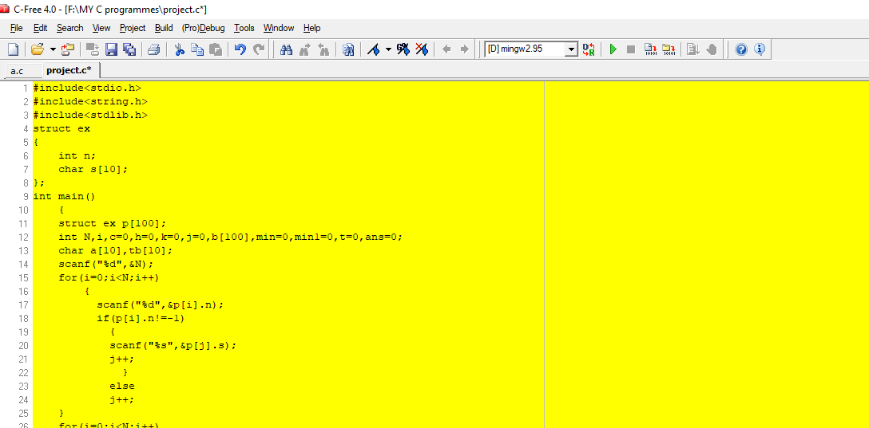

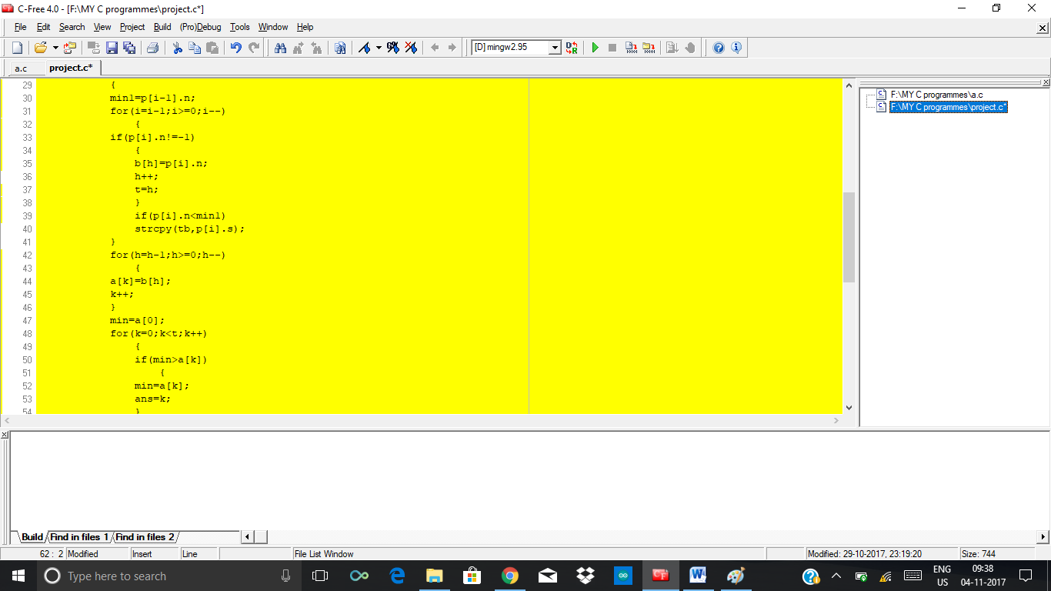

**SAMPLE TEST 1**

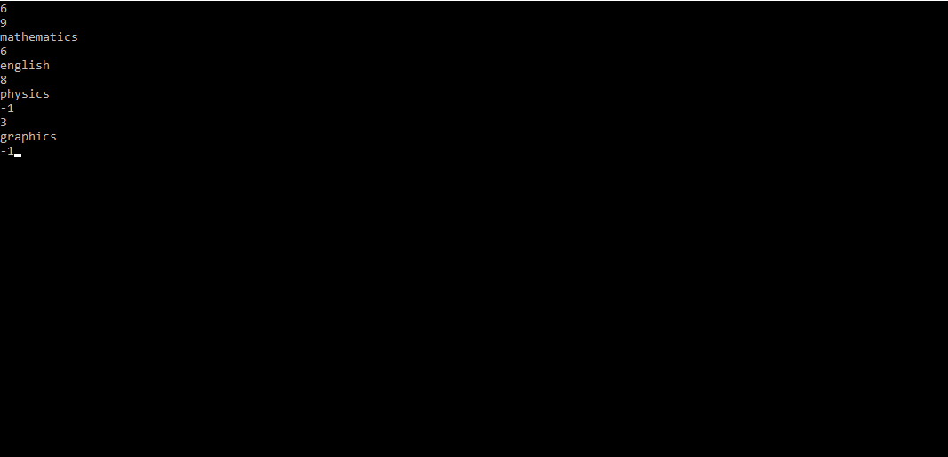

**OUT PUT 1**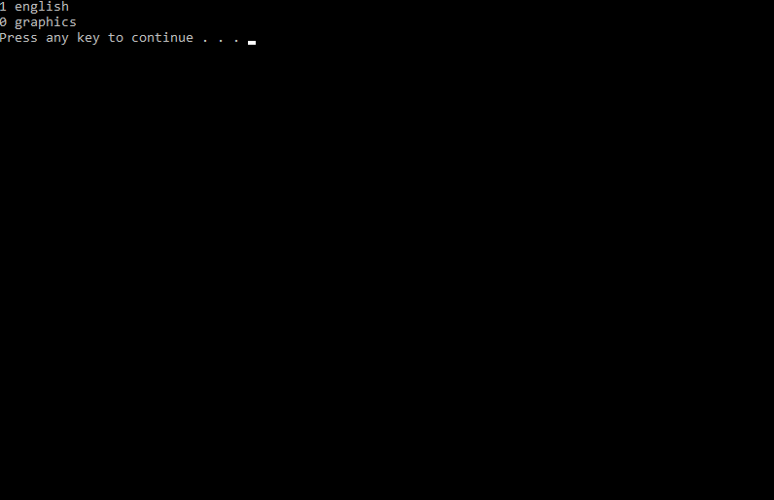

**SAMPLE TEST 2**

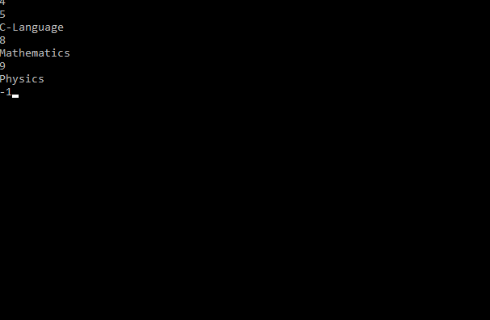

**OUTPUT 2**

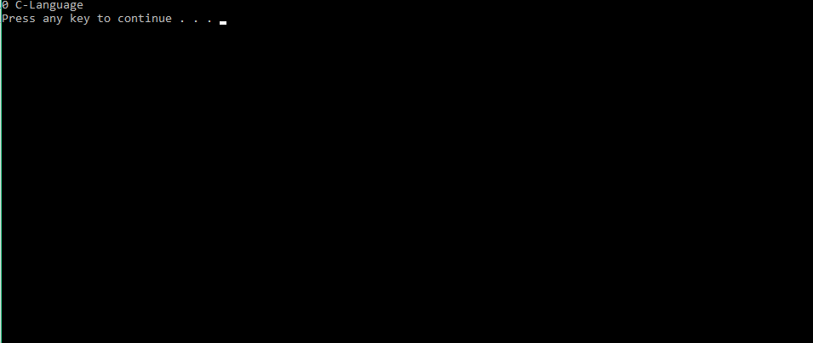

**SAMPLE TEST 3**

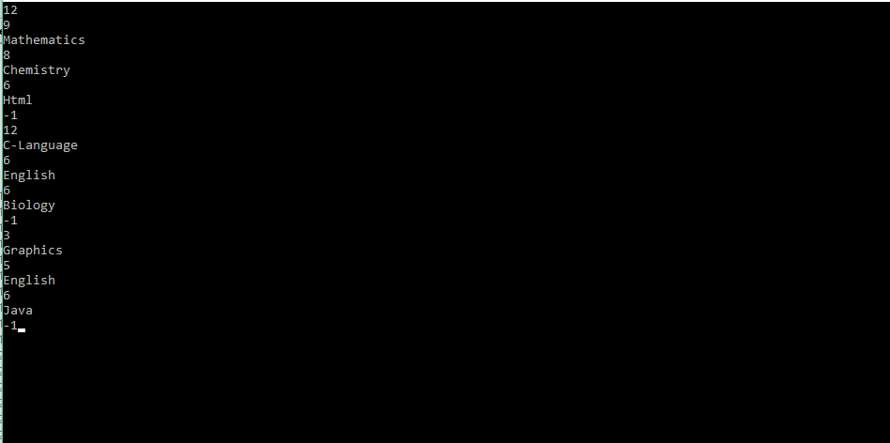

**OUTPUT 3**

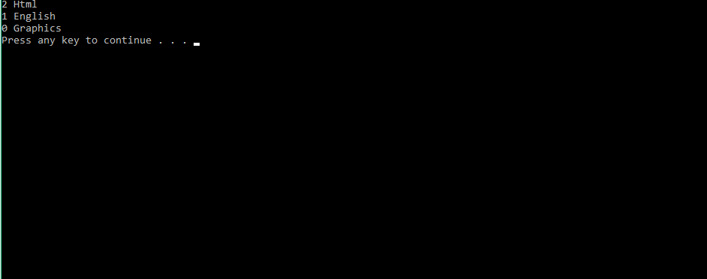

**CONCLUSION**

We hereby conclude that this project is done by us with the help of our faculty we have done this project to help harry to arrange the books in order and to read them by using the conditions given in the question. These type of programs are useful in the future. If we have better compilers the usage of the programs will be more efficient. So if we use better compilers then the output becomes correct and becomes fast and if use languages other than c like python, java we are thinking that the program will be less and the time complexity is reduced. This type of program used in the arrangement of books is used in many other situations in games (some games are using this program). So in future these programs will become more useful.